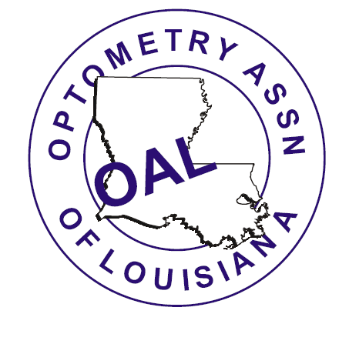
Optometry Association of Louisiana
2011 Annual Convention
June 10-12, 2011

Thomas & Melton’s
“Current Therapy in Ocular Disease”
A Comprehensive Clinical Update of
Glaucoma & Anterior Segment Disease

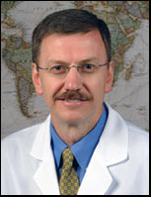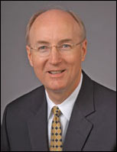

Ronald Melton, OD, FAAO / Randall Thomas, OD, MPH, FAAO

Belle of Baton Rouge Casino
Convention Center Hotel
(Formerly Sheraton Hotel)

102 France Street, Baton Rouge, Louisiana 70802 • (225) 242-2600

16 Hours CE for TPA
13 Hours Paraoptometric CE

Friday Night Exhibit Hall
Saturday Night Social
The Optometry Association of Louisiana acknowledges & thanks the following corporate partners for providing educational grants &/or considerable exhibit hall support for our 2011 Annual Convention. Please thank & support these fine groups who support organized optometry & you!
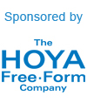




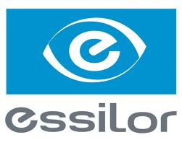
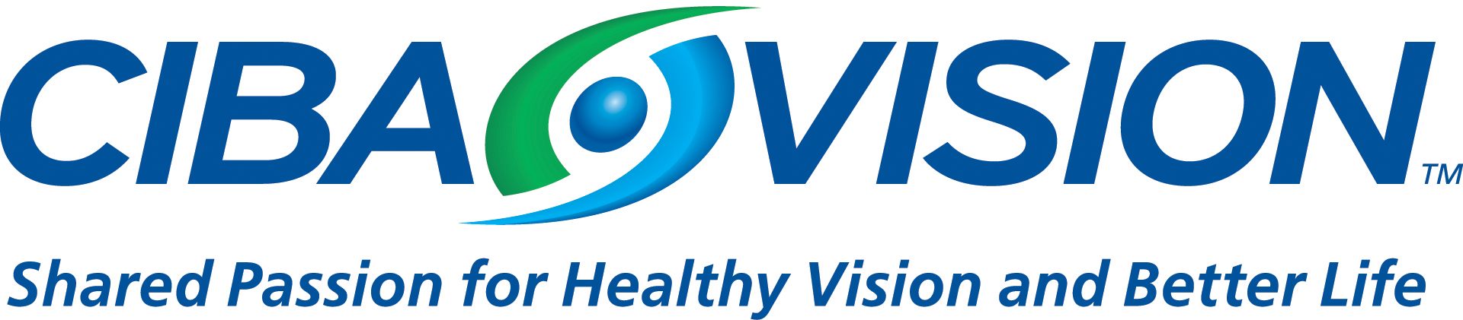

 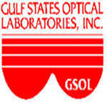 Demandforce

Optometry Association of Louisiana
2011 Annual Convention
Thomas & Melton’s “Current Therapy in Ocular Disease”
Finalized 6-7-11
OPTOMETRISTS PROGRAM

This 16-hour comprehensive update course will be an intensive discussion relating to glaucoma and anterior segment disease management. It is our goal for you to leave here at the conclusion of this course armed with enhanced knowledge, clinical skills, and enthusiasm regarding patient care. We trust this new knowledge will build on a patient care foundation of trust, competence, and compassion that has no equal. We hope you have an enjoyable time during this educational event. Thank you for being a part of what we trust will be the best course you have ever attended. –Randall Thomas & Ron Melton

Thursday, June 9
6:00 p.m. OAL Board of Directors Meeting

Friday, June 10
7:00-8:00 AM. Registration & Continental Breakfast

8:00-10:00 AM Comprehensive Pharmacology Update
This course reaches the cutting edge of contemporary medical management with topical and oral drugs used to treat eye disease. Clinical application of the pharmaceuticals is stressed with case presentations. Included is a review of all relevant drug classes as well as an update on what is new.
2 hr TPA COPE #25919-AS

10:00-Noon DRUGS: Just Say “KNOW”
This course outlines the litany of ophthalmic drugs, clinical usage, research efficiency and potential side effects. Discussions will detail topical & oral steroid use, dry eye & OSD treatments, antivirals, “off label” use of medications, Betadine regimen for viral keratoconjunctivitis, and the treatment of ocular allergy.
2 hr TPA COPE #25920-PH

Noon-1:00 PM Luncheon for ODs SWCO Report: SWCO Representative
SECO Report: Dr. James Herman, Treasurer, SECO International

1:00-3:00 PM Separating the Good, the Bad and the Ugly: “Is It Glaucoma or Not”
This course provides an update on the diagnosis and management of glaucoma. Included in the discussion will be epidemiology, recent studies, risk factors, clinical evaluation, visual fields, treatment goals, medications and case evaluations.
2 hr TPA COPE #25921-GL Sponsored by SECO International

3:00- 4:00 PM OAL Annual Members Meeting

4:00- 7:00 PM Exhibit Hall with Food, Drinks & “Passport to Prizes” Drawing
OD Grand Prize: OptiKam (valued at over $7,500) donated by HOYA

9:00pm-Midnight Hospitality Suite Open Garden Atrium Sponsored by HOYA
Saturday, June 11
7:00-8:00 AM. Registration & Continental Breakfast
Past Presidents Breakfast (By Invitation Please) Sponsored by Vision Source
Livingston Room

8:00-10:00 AM Reducing the Pressure on Glaucoma Decision-Making
This course reaches the cutting edge of contemporary medical management of glaucoma by presenting numerous cases. An update on diagnostic and treatment pearls as well as a review of important medications used to treat glaucoma will be discussed as part of the case presentations.
2 hr TPA COPE #25922-GL Sponsored by VSP

10:00-Noon Not So Trivial Pursuits: How to Conquer Anterior Segment Disease
This team-taught course will present numerous clinical cases of common and not so common anterior segment disease entities seen in our practices. The differential diagnosis and medical management options of each case will be discussed in a clinical practice manner. Emphasis will be given to the latest treatment options for the presented anterior segment topics.
2 hr TPA COPE #25925-AS

Noon-2:00 PM Luncheon with installation of OAL Officers (All Registrants Invited)
Keynote Address: Dr. Sam Pierce, AOA Trustee (Alabama)

2:00-3:00 PM Student Roundtable Discussion w/ State Leaders (remain in dining room)

2:00-4:00 PM New Horizons in the Treatment of Ocular Surface Infection and Inflammation
This team-taught course will present an interesting array of anterior segment cases we have diagnosed and treated in our offices. Patient presentations have been selected for maximum educational and patient care enhancement.
2 hr TPA COPE #25926-AS

4:00-5:00 PM Louisiana State Board of Optometric Examiners Annual Meeting

6:00 PM Cajun Night Social (Belle of Baton Rouge Casino Hotel)
It’s a Cajun Dance & Food Party for the whole family! Come and enjoy all the boiled
crawfish, boiled shrimp, fried catfish & jambalaya you can eat with live music. Tickets are only $25 per person (Children 12 & under are free!) Purchase your tickets when you register for the meeting!

Sunday, June 12
7:00-8:00 AM Registration & Continental Breakfast

8:00-10:00 AM Melton-Thomas Treatment Guidelines
The Melton-Thomas team discusses some of the common and not-so-common disorders often seen in the primary care optometric practice. Current information and recommendations are discussed regarding approved drugs and treatment modalities.
2 hr TPA COPE #27684-PH

10:00-Noon Final Destination: Turbo-Charge Your Treatment
This course covers a wide array of clinical presentations seen in the optometric practice. The differential diagnoses of case presentations and the relevant management strategies will be discussed. Both topical and oral therapies will be used to reach the final destination of treatment success.
2 hr TPA COPE #27686-AS
Biographical Sketch of the Lecture Team

Drs. Melton and Thomas are North Carolina natives. They completed their training at the Pennsylvania College of Optometry in 1981. They have attended the Armed Forces Institute of Pathology Course in “Ophthalmic Pathology for Ophthalmologists.” Both were members of the Student Optometric Service to Haiti team in 1981. They have successfully completed the National Board Examination in Optometry and the International Association of Boards of Examiners in Optometry Examination on “Treatment and Management of Ocular Disease.”
They have been honored as the “Glaucoma Educators of the Year” by the American Academy of Optometry. The William C. Ezell Award “For the Best Article Based upon a Lecture Given at the Southern Congress of Optometry” was presented to them by the Southern Council of Optometrists. They are Fellows in the American Academy of Optometry. Both served as consultants to the Council on Clinical Optometric Care and the Council on Optometric Education of the American Optometric Association. They have been consultants in the areas of pathology and ocular pharmacology to the International Board of Examiners in Optometry. Both are members of the adjunct faculty at the Pennsylvania College of Optometry, Pacific University College of Optometry, and State University of New York College of Optometry.
They have lectured throughout the United States and internationally on the topics of ocular differential diagnosis and medical management of the eye diseases. Together they have authored many articles in the optometric literature, including the annual “Clinical Guide to Ophthalmic Drugs” in Review of Optometry. Drs. Melton and Thomas are full-time clinicians delivering primary and secondary eye care.

RON MELTON, OD, FAAO
Dr. Melton served as a Captain in the U.S. Army as a clinical optometrist at Hawley Army Hospital in Indianapolis, Indiana from 1981 to 1984. Currently he is in a group practice in Charlotte, North Carolina, where he has staff privileges at Presbyterian Hospital. He is a member of the adjunct faculty of the Indiana University School of Optometry. He and Annie have two daughters and one son.

RANDALL THOMAS, OD, MPH, FAAO
Dr. Thomas served as a Captain in the U.S. Air Force as a clinical optometrist at Bolling Air Force Base in Washington, D.C. from 1981 to 1984. Dr. Thomas is in a group practice in Concord, North Carolina, and serves as the Ophthalmic Drug Consultant for the Pharmacy and Therapeutics Committee of North Carolina Blue Cross and Blue Shield. He is on the hospital staff at Northeast Medical Center, where he serves as the Ophthalmic Consultant to the Diabetes Management Committee, and actively teaches on the Cabarrus Family Medicine Residency Faculty. He and Cheryl have two daughters.

